**Final Project - Devops**

**Names:**

חן צלח**: 208730812**

תומר בן שמעון**: 316015742**

גטש מאנאי**: 327352068**

Your git repository + URL

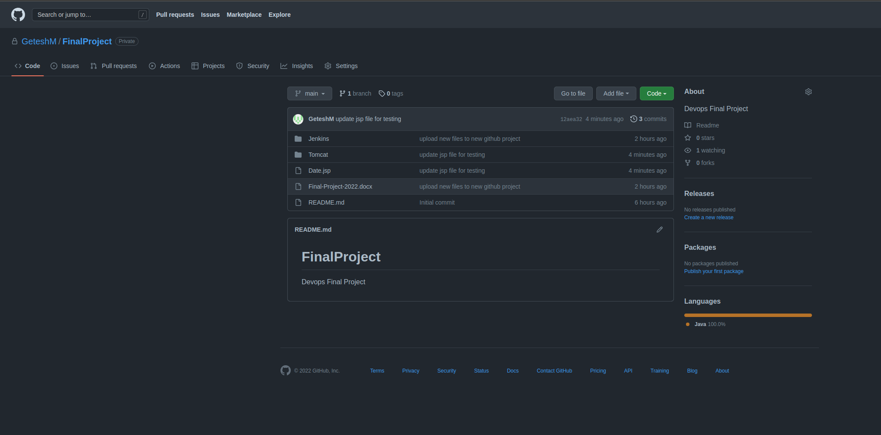

URL - <https://github.com/GeteshM/FinalProject.git>

Jenkins web page

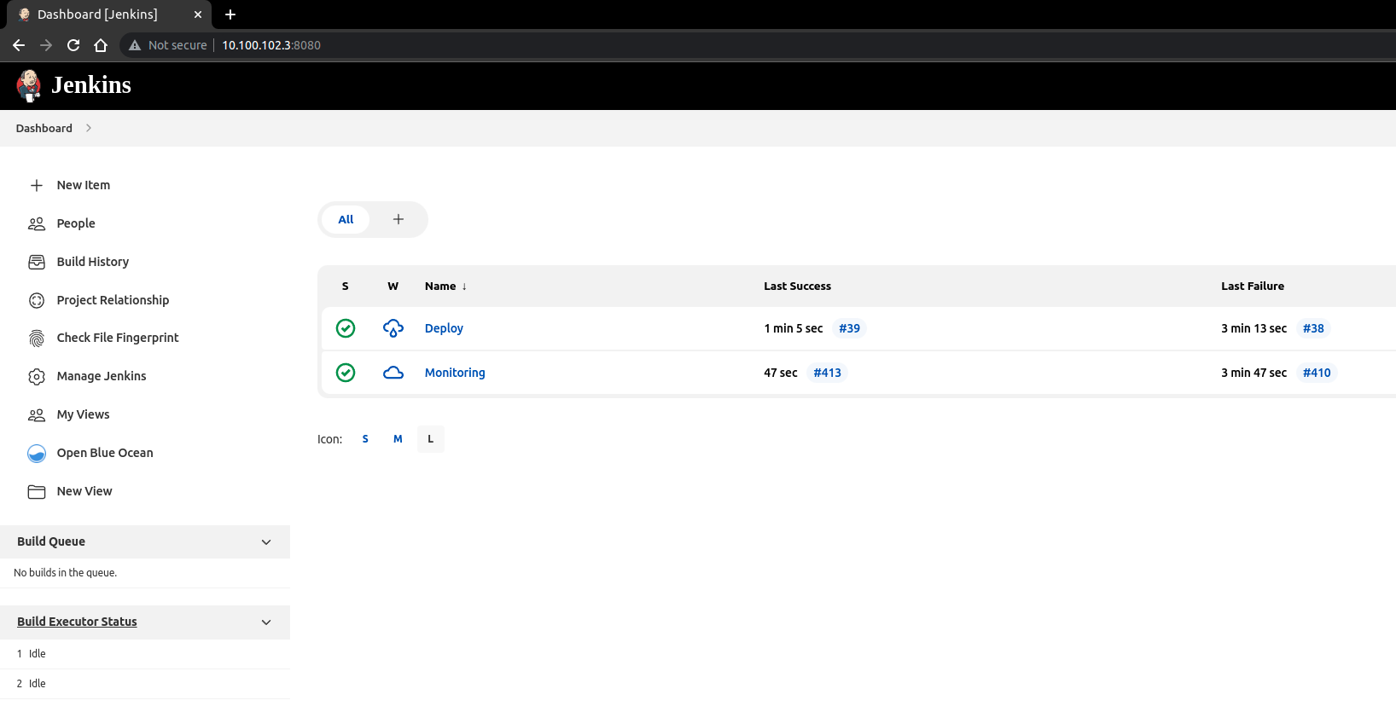

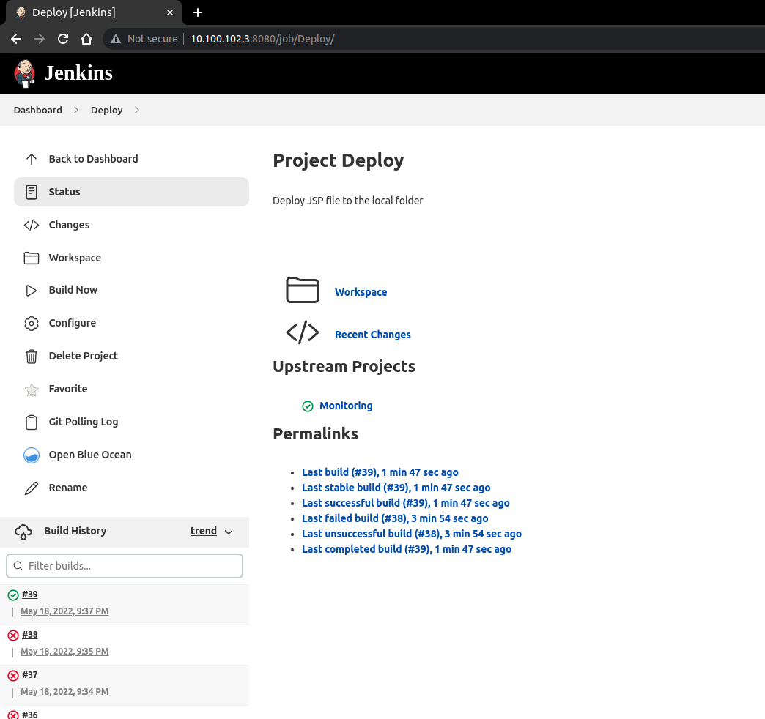

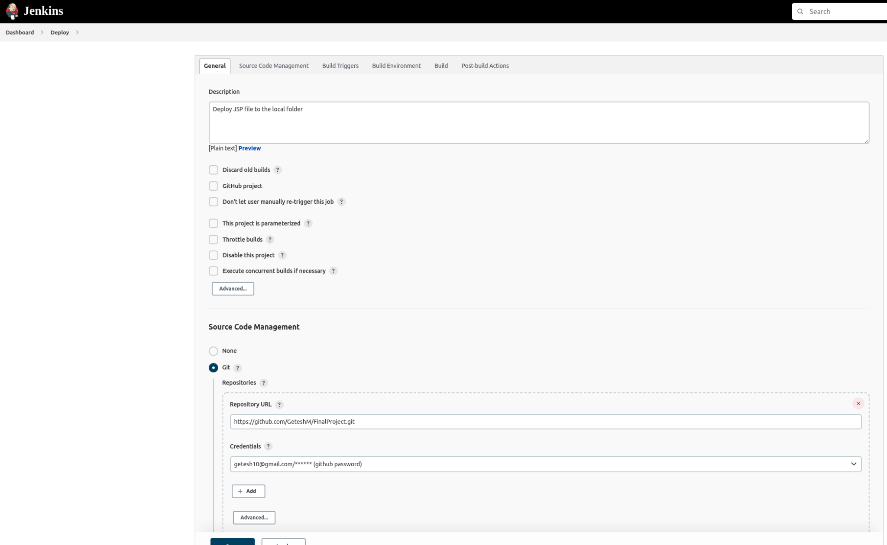

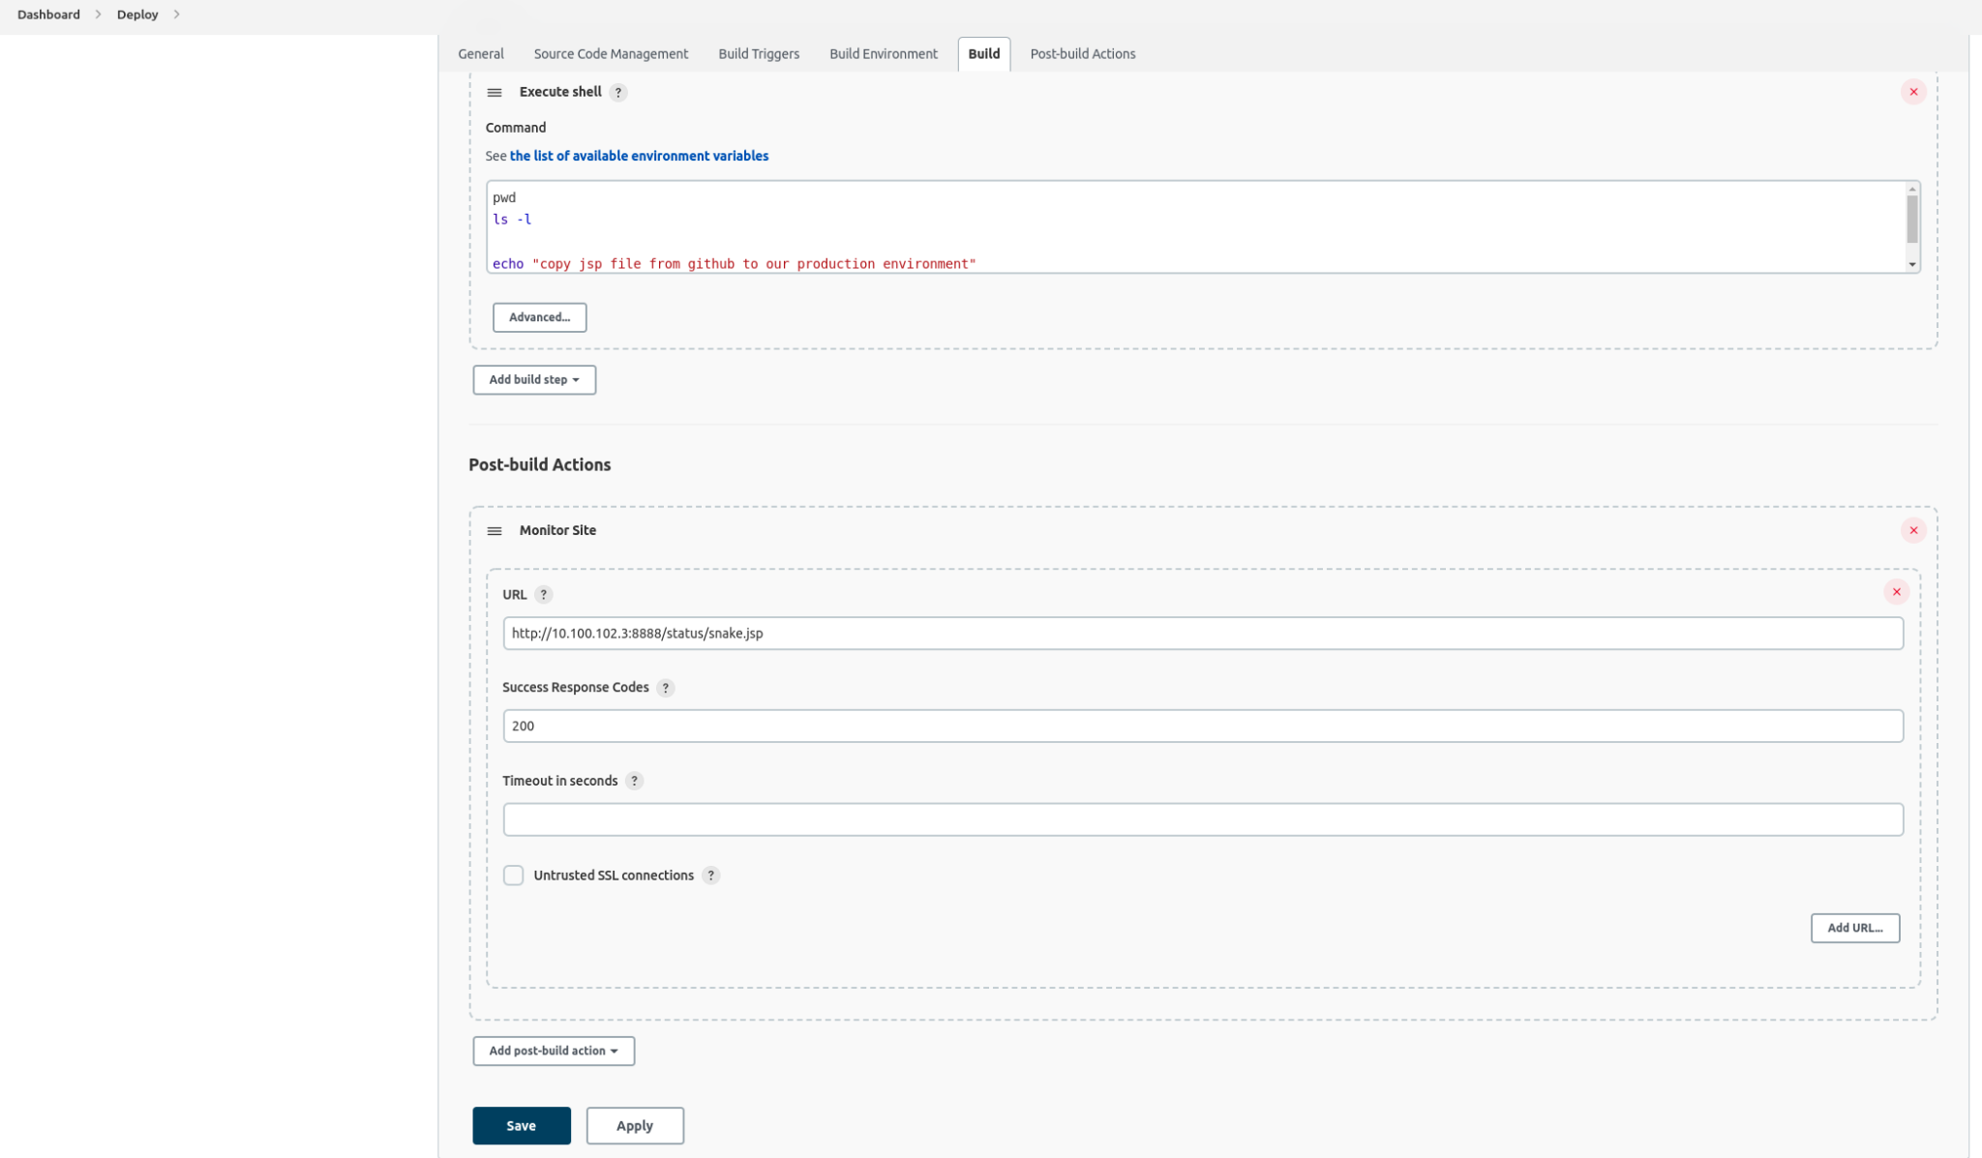

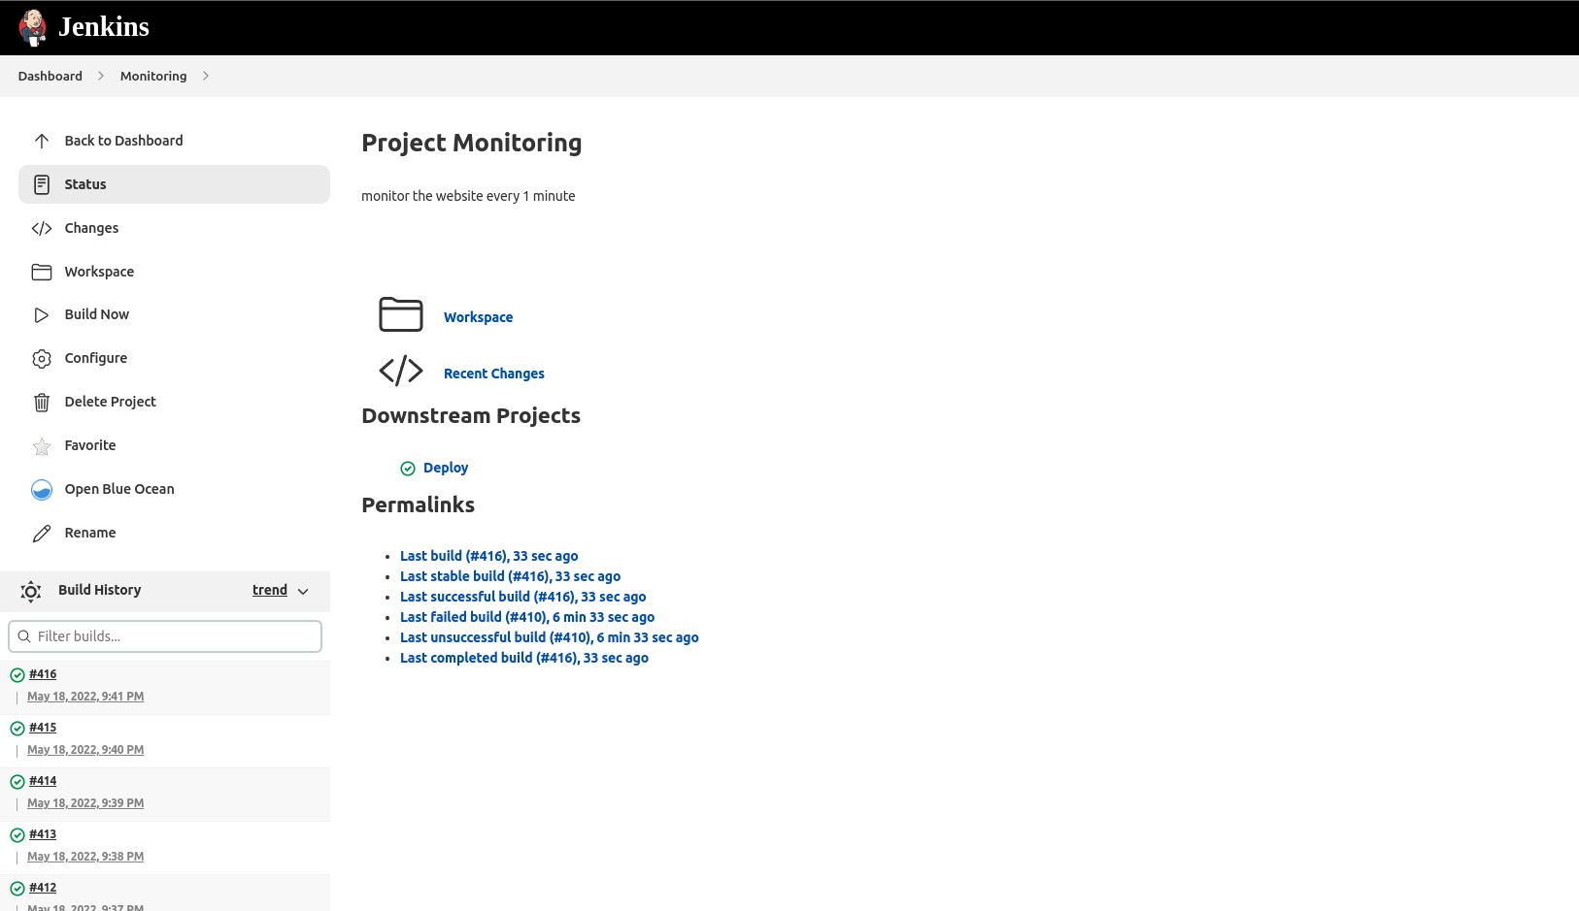

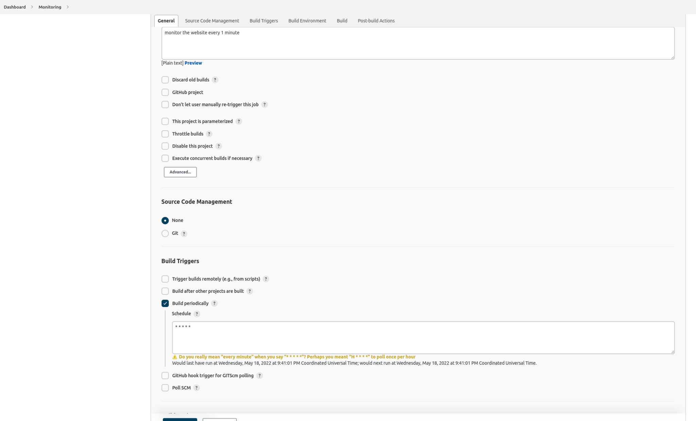

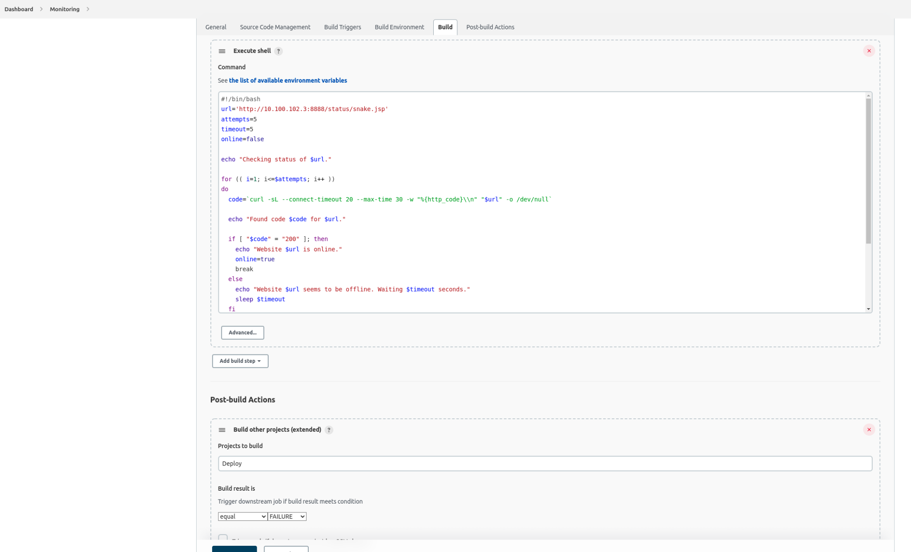

Tomcat web page (with your application)

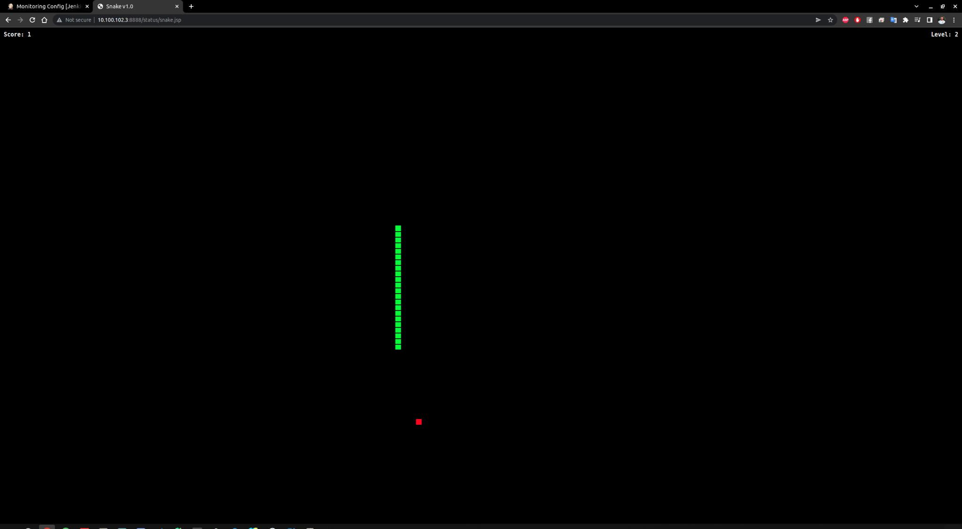

Run docker ps ( with command output)



Your docker-compose file

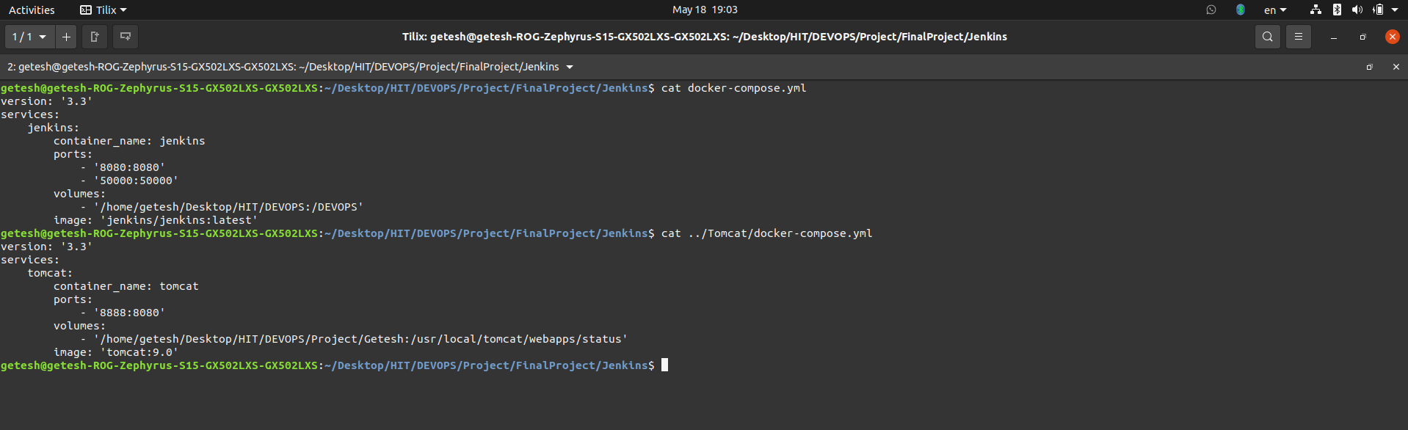

Monitor result

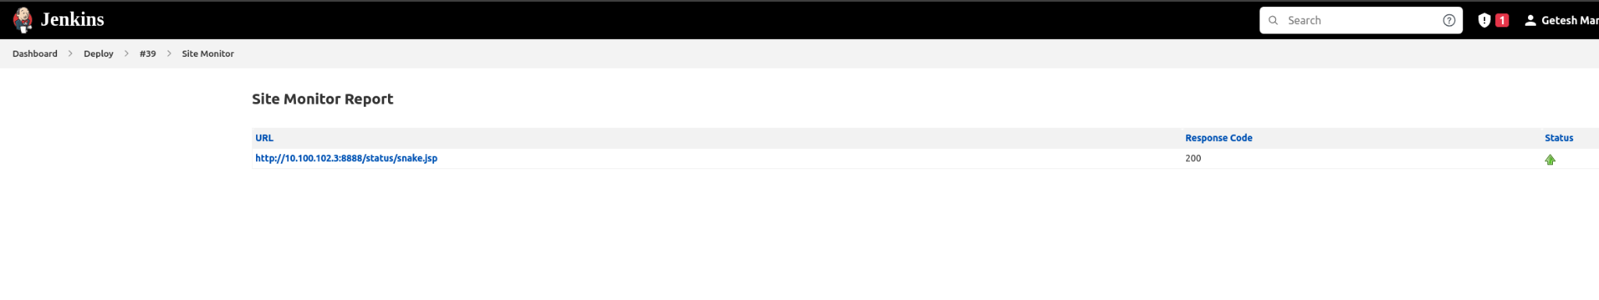

Second Monitor Job result

